

Redbox
OpenAPI OAuth Authentication & Authorization Design – R1
Architecture Design
Author: Chris Rudolphi
Document Title: OpenAPI OAuth Authentication and Authorization Design – Draft 7
Updated: 8/26/2011 9:19 AM

Reviewer and Approvers
Name | Title/Role | Reviewer/  Approver | Approval  Date | Approval Method
Saad Rehmani | Director of Architecture | Approver
Gunhan Tatman | VP of Development | Approver
Bart Dolega | Director of Platform Services | Approver
 | Product Manager | Reviewer

Table of Contents
1. OpenAPI Authentication & Authorization 4
1.1 Overview 4
1.2 References 4
2. Design 4
2.1 Federated Authentication Protocol 4
2.2 OAuth Protocol 4
2.3 Components 6
2.3.1 Overview 6
2.3.2 Client 6
2.3.3 Apigee 6
2.3.4 Authorization Server 7
2.3.5 OpenAPI Server 7
2.3.6 Federation Provider 7
2.3.7 Identity Provider 7
2.4 Use Cases 8
2.4.1 User Begins New Session with First Visit to a Web Client Application 8
2.4.2 Client Issues Calls to OpenAPI operations that do not Require User Authentication 9
2.4.3 CE/Mobile device Client Issues Calls to OpenAPI 9
2.4.4 Batch Client Issues Calls to OpenAPI 9
2.5 Authentication Flows 11
2.5.1 Auth_Code 11
2.5.2 Implicit 12
2.5.3 SAML Bearer 13
2.5.4 Client_Credentials 14
2.5.5 Refresh Token 15
3. Operation Descriptions for OAuth Implementation 16
3.1 Apigee OAuth Operations 16
3.1.1 Client-Facing OAuth Operations 16
3.1.2 Auth_Server Facing Operations 30
3.2 Redbox Auth_Server Operations 35
3.3 XML Payload Protection 41
3.4 Audit Policy Configuration 41
3.5 Log Policy Configuration 42
3.6 Replay Threat Configuration 42
4. Schemas 43
4.1 AuthorizationResult 43
4.2 AuthCodeResponse 46
4.3 AccessTokenResponse 47
5. Change Log 48

OpenAPI Authentication & Authorization

Overview
Open Services encompasses two logical components: an Authorization Server and the OpenAPI services. The Authorization Server will delegate user authentication to an Identity Provider using the Federated Authentication protocol. It will also provide a mechanism for the user to grant consent to the application for access to their information to support the OAuth protocol. The Identity Provider is a Security Token Service that provides authentication using a log in page. The OpenAPI services are the collection of REST services comprising the API. The development of OpenAPI encompasses the development of these three components.

References
This design is based upon the implementation of several standards:
- WS-Federation2007: http://docs.oasis-open.org/wsfed/federation/v1.2/os/ws-federation-1.2-spec-os.html
- OAuth2.0 Draft 13: http://tools.ietf.org/id/draft-ietf-oauth-v2-13.txt
- OAuth2.0 Bearer Tokens (Draft 8): http://www.ietf.org/id/draft-ietf-oauth-v2-bearer-08.pdf
- SAML2.0 Bearer Assertion Profiles for OAuth 2.0 (Draft 5): http://tools.ietf.org/pdf/draft-ietf-oauth-saml2-bearer-05.pdf
WS-Federation (#1) is used in this design to manage the authentication of browser-based users. OAuth (#2) is used to authenticate and authorize access to the OpenAPI web-services. #3 describes how access-tokens generated via OAuth are presented by clients to the OpenAPI web-service endpoints. SAML tokens can be used in lieu of a user’s username/password as described in #4.

Design

Federated Authentication Protocol
Federated Authentication is largely concerned with externalizing user authentication from an application that consumes it. This allows a user to log into multiple different applications with the same credentials as well as allowing a user to log in to an application with multiple different sets of credentials. It also makes possible single sign on behavior with applications if different domains. Federated Authentication makes use of SAML tokens which represent a user’s identity in the form of claims. Clients can authenticate a user in one of two ways. The first is an active mode in which an application invokes calls to a Security Token Service, STS, endpoint directly. The other is a browser-based approach which relies on a series of 302 redirects and JavaScript induced posts to accomplish the same thing. This is the approach that is needed for this design. A full discussion of Federated Authentication is beyond the scope of this document, but it is important to know how it is implemented since it will be necessary to host a security token service endpoint to facilitate user authentication. This is discussed in more depth later. For now be aware that most of this functionality is made possible with the use of Windows Identity Foundation, WIF.

OAuth Protocol
The OAuth protocol defines four components (called roles) that are coordinated to secure access to a protected resource. A protected resource is any resource (such as a user’s profile information) that is provided to a client. A client is the role that consumes the protected resource. The client is therefore the application making calls to OpenAPI. A resource owner is the role with exclusive ownership of a protected resource. In this design, the resource owner is the user accessing the application. A resource server is the role that protects the resource. The resource server is the OpenAPI restful services that provide access to the resource requested by the application (which has been previously granted by the user). Even though the user owns the resource, the resource is stored with the resource server and the user implicitly trusts that the resource server will not divulge this information to any client without their explicit permission. Finally, an authorization server is the role that authenticates the user and grants permission to the client for access to the resource on behalf of the user. The granting of permissions is also referred to as providing user consent. Consent to resources can be coarse or fine grained which is referred to as scopes. For example, a user may grant permission to an application to access profile information but not the right to reserve movies.

Components

Overview
OpenAPI must authenticate not only the user accessing the API but also the client application. The application will always be authenticated by the Apigee portion of OpenAPI using a client id and secret. Before a new application is granted access to OpenAPI this information will be provided to Apigee. The authorization server will authenticate the user at the beginning of a user’s session using the Federated Authentication protocol. It will also provide a way for the user to grant the application access to their information. Successful authentication will result in a SAML token sent to the client. The client will then exchange this token for an OAuth access token which is used to authenticate the user for subsequent API calls during the user’s session using the OAuth protocol. Since all calls to OpenAPI are proxied through Apigee, Apigee will be responsible for exchanging the tokens and authenticating the user with subsequent requests. This simplifies the roles of the authorization server and the API server. The authorization server will simply perform Federated Authentication and grant access to applications. The API server will simply host the REST server endpoints.

Figure 1 : Open Services and Dependency Components

Client
The client is the application that the user interacts with through a browser. The client will issue calls directly to the Apigee layer of OpenAPI hosted in the cloud by Apigee.

Apigee
Apigee is the layer that faces the internet and exposes the OpenAPI service endpoints. It is responsible for authenticating both the client application and the user with the use of their key manager during a user’s session. The initial user authentication, however, is passed through to the Authorization Server. During the user’s session Apigee will also pass the client id and user id through to Open Services. This simplifies the design by defining distinct responsibilities for the Apigee and Open Services layers of OpenAPI.

Authorization Server
The Authorization Server is responsible for kicking off the Federated Authentication sequence which involves the use of the Federation Provider and the Identity Provider. Since authentication will occur during a user’s browser session, the authentication will occur using the passive profile which relies on a series of browser redirects and JavaScript induced posts to propagate a user’s identity. The Authorization Server will also host the grant page that allows the user to grant the client application access to their information. The grant page will have the same look and feel as the Redbox.com web site which means it may need to share UI assets. The Authorization Server will be an ASP.NET MVC application that hosts both this service endpoint and the grant page.

OpenAPI Server
The OpenAPI Server will host all the service endpoints that comprise the OpenAPI services. It will receive calls that are proxied through Apigee. Since Apigee is responsible for authentication during a user’s session, the OpenAPI Server will only be responsible for responding to service calls. Apigee will forward the user id and application id within a set of custom HTTP headers with every request.

Federation Provider
STS servers are generally categorized as either a Federation Provider or an Identity Provider. The Identity Provider is responsible for user authentication while the Federation Provider is responsible for relaying a user’s identity from an Identity Provider to the Relying Party which requested the user’s identity. The Relying Party in this design is the Authorization Server. Federation Providers are useful for establishing trust relationships with Identity Providers and Relying Parties hosted in different domains. With this design, the Federation Provider will be hosted within the Microsoft Cloud using Azure’s Access Control Service, ACS. No custom development is needed. ACS only needs to be configured with the proper trust relationships with the Identity Provider and Relying Party.

Identity Provider
The Identity Provider will be responsible for authenticating users at the beginning of a user’s session using Federated Authentication. As a result it will also display the login page. Using passive authentication, the Identity Provider does not initially get accessed directly. The Authorization Server will first direct the browser to the Federation Provider which in turn directs the browser to the Identity Provider. Based on the trust relationships between different Identity Providers, this is necessary to provide cross domain authentication. Each redirect wraps the request with an additional return URL so that the browser can make its way back to the server that initiated the log in sequence. The Identity Provider will also support an active authentication endpoint which allows a non-browser based applications to invoke WS-Federation standard Federated Authentication calls to the Federated Provider and Identity Provider directly without the need to rely on browser redirects and posts. Active authentication flows will be added in a subsequent release.

Use Cases

User Begins New Session with First Visit to a Web Client Application
Given: Client does not have an access token and user has no pre-existing consent for the application
When: Client calls \\api.redbox.com\authorize?response_type=code&client_id=XXX on the Apigee Gateway
Then: Apigee Gateway redirects client (including all headers & cookies) to \\Authorization Service\authorize?response_type=code&client_id=XXX
Given: Client does not have an access token (regardless of existence of pre-existing consents)
When: Client calls \\api.redbox.com\token?grant_type=token&client_id=XXX on the Apigee Gateway
Then: Apigee Gateway authenticates client_id
Apigee Gateway redirects call (including all headers & cookies) to \\Authorization Service\authorize?response_type=token&client_id=XXX
Given: Request does not include any pre-existing FedAuth cookies;
When: Apigee gateway redirects request to Authorization Service/authorize (upon either a call to /authorize?response_type=code OR to /token?grant_type=token)
Then: WIF FAM module on Authorization Service intercepts request and redirects to ACS to kick-off passive federated authentication
Given: FedAuth cookies are present (user is now authenticated to Authorization Service); application is exempt from consent
When: Apigee Gateway redirects call to Authorization Service/authorize
Then: Authorization Service skips permission page and informs Apigee Gateway of the consent and scopes
Given: FedAuth cookies are present (user is authenticated to Authorization Service); no user consent pre-exists for the application requiring consent
When: Apigee Gateway redirects call to Authorization Service/authorize (regardless of response_type)
Then: Authorization Service displays permissions page
Given: FedAuth cookies are present (user is authenticated to Authorization Service); user has pre-existing application consent for application requiring consent
When: Apigee Gateway redirects call to Authorization Service/authorize with response_type != token
Then: Authorization Service skips the permission page and informs Apigee Gateway of the consent & scopes
Given: FedAuth cookies are present (user is authenticated to Authorization Service); user has pre-existing application consent for application requiring consent
When: Apigee Gateway redirects call to Authorization Service/authorize with response_type == token
Then: Authorization Service displays permissions page
Note: The above is necessary since the client app has not been fully authenticated, we ALWAYS ask the user to grant permission to the app, regardless of whether they have previously granted access to that same app.
Given: Authorization Service has displayed permission page
When: User grants consent
Then: Authorization Service records permission in the consent data store (UserConsent table and Audit table)
Authorization Service informs Apigee Gateway of the consent & scopes
Given: Authorization Service has displayed permission page
When: User denies consent
Then: Auth Service records denial in Audit
Authorization Service informs Apigee Gateway of the denial

Client Issues Calls to OpenAPI operations that do not Require User Authentication
Given: Client does not have an access token
When: Client issues a call to Products, Stores, Top20, or Inventory but does not provide client_id & client_secret as query string params
Then: Apigee Gateway issues a 401 Unauthorized status code, along with a WWW-Authenticate header with a value of “Bearer”
Given: Client does have an access token
When: Client issues a call to Products, Stores, Top20 or Inventory
Then: Apigee Gateway authenticates access token before processing the request

CE/Mobile device Client Issues Calls to OpenAPI
Given: Client does not have an access token
When: Client issues a call to OpenAPI
Then: Apigee Gateway issues 401 Unauthorized status code (per Bearer tokens extension to OAuth2.0 standard )
Given: Client has a SAML2.0 token issued by ACS
When: Client calls Apigee Gateway/token?grant_type="urn:ietf:params:oauth:grant-type:saml2-bearer" and includes the SAML2.0 token in the request (per IETF draft draft-ietf-oauth-saml2-bearer)
Then: Apigee Gateway authenticates client_id & client_secret
Apigee Gateway forwards the request to Authorization Service/SAMLAuthorize
Given: Client has a SAML2.0 token issued by ACS and has called Apigee Gateway/token
When: Apigee Gateway forwards a Client submitted SAML2.0 token issued by ACS
Then: Authorization Service confirms the integrity of the SAML2.0 token
Authorization Service looks for pre-existing application consent; constructs one if not found
Authorization Service informs Apigee Gateway of the consent & scopes

Batch Client Issues Calls to OpenAPI
Given: Client does not have an access token
When: Client issues a call to OpenAPI to Inventory or Customer
Then: Apigee Gateway issues 401 Unauthorized status code with WWW-Authenticate: Bearer header
Given: Client does not have an access token
When: Client issues a call to Products, Stores, Top20, or Inventory but does not provide client_id & client_secret as query string params
Then: Apigee Gateway issues 401 Unauthorized status code with WWW-Authenticate: Bearer header
Given: Client does not have an access token
When: Client calls Apigee Gateway/token?grant_type=client_credentials
Then: Apigee Gateway authenticates client_id & client_secret; validates that client_id is authorized to use ‘client_credentials’; issues token

Given: Client does have an access token
When: Client issues a call to Products, Stores, Top20 or Inventory
Then: Apigee Gateway authenticates access token before processing the request
Given: Client does have an access token
When: Client issues a call to Reservation or Customer or Partner API operations
Then: Apigee Gateway authenticates access token before forwarding the request to OpenServices

Authentication Flows
This section provides sequence diagrams that describe the interaction between the components for each of the four profiles supported and the sequence for Token Refresh:

Auth_Code
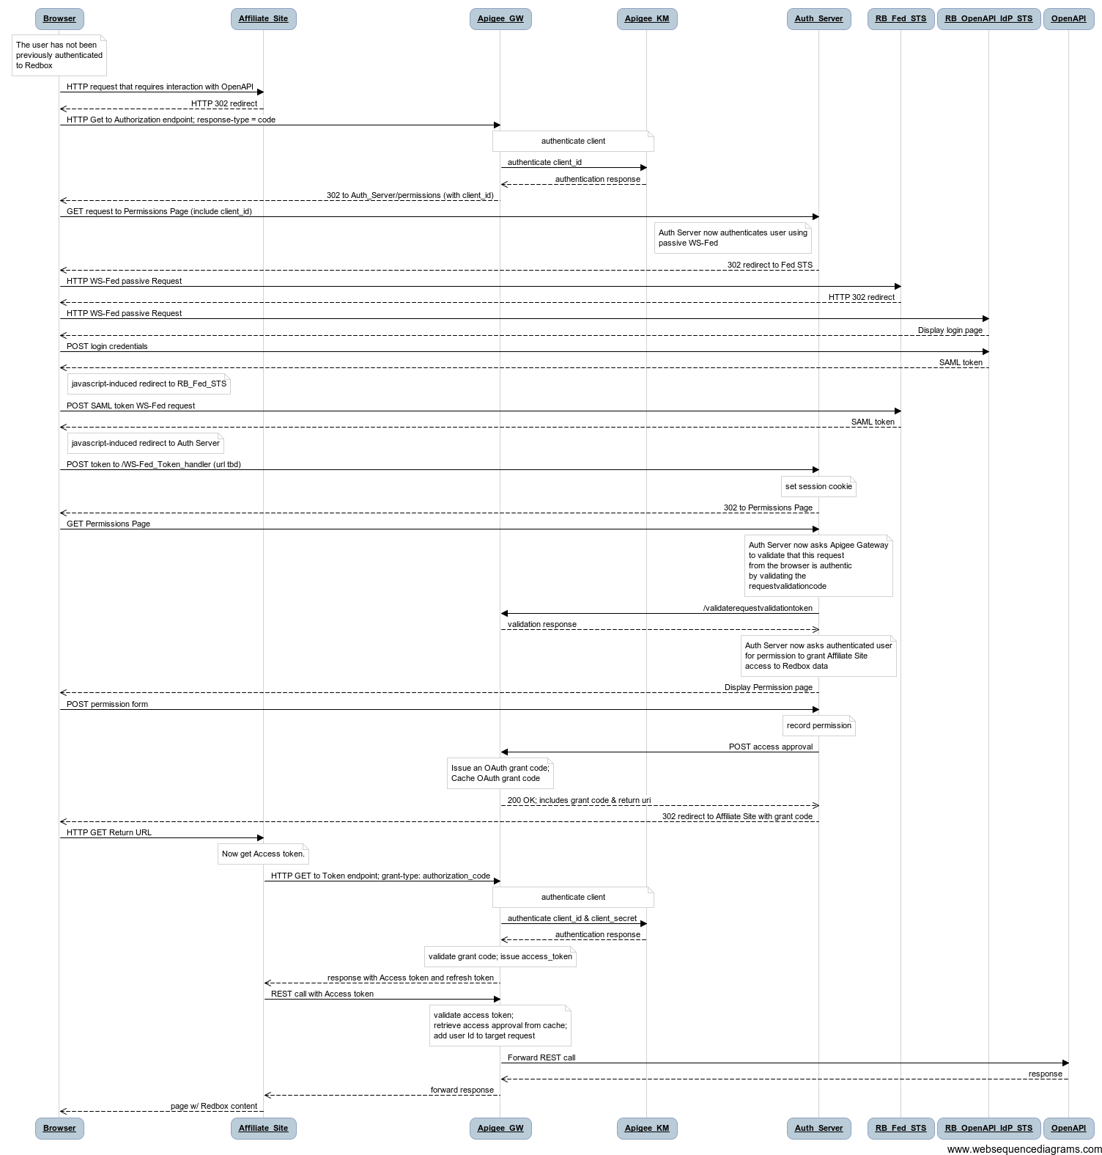

Implicit
Note: this profile is low-priority and may be dropped from scope.
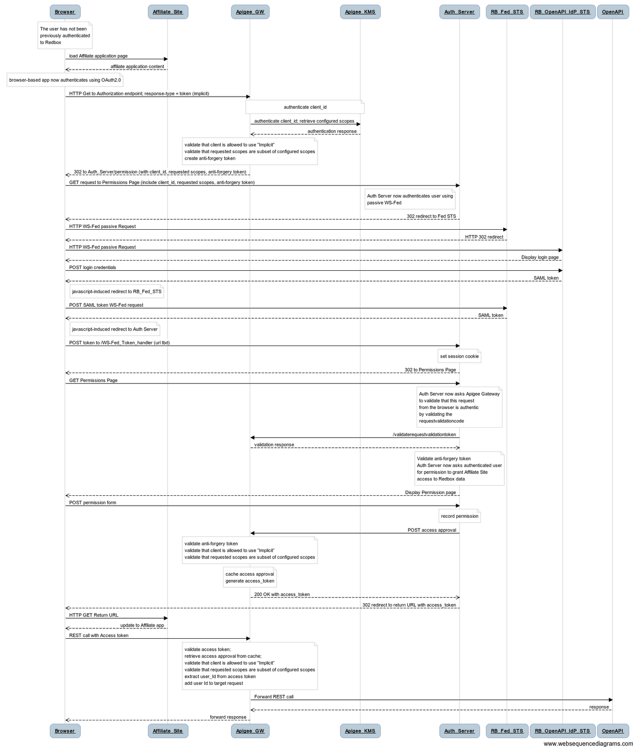

SAML Bearer
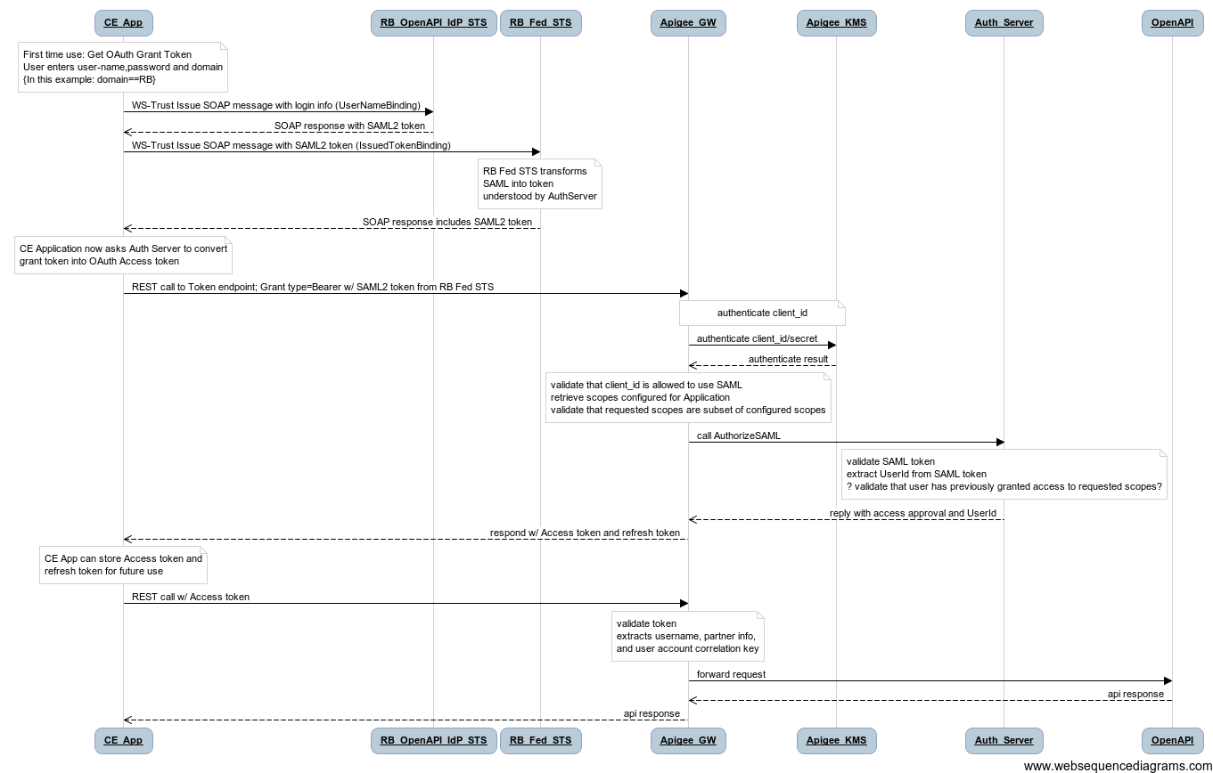

Client_Credentials
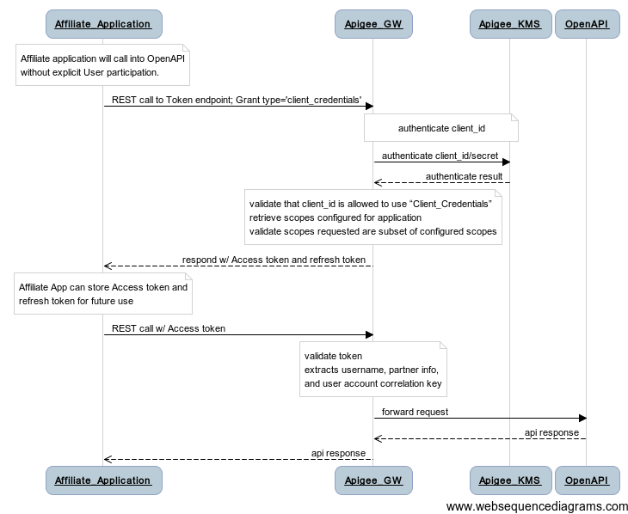

Refresh Token
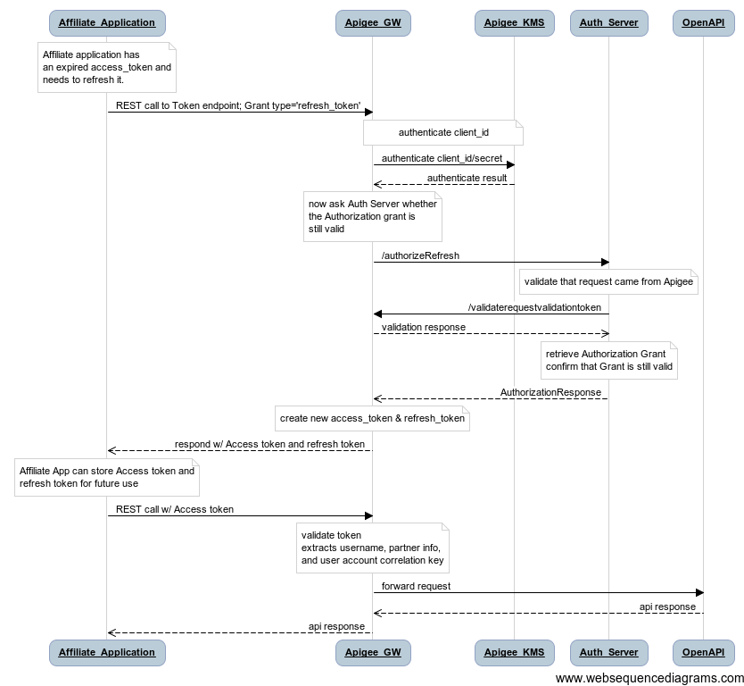

Operation Descriptions for OAuth Implementation
This section documents the operations that implement the OAuth protocol.
These descriptions should be used as a conceptual reference, not a mandatory definition of how the operations should be constructed.

Apigee OAuth Operations
These operations are split into two sections. The first describes the OAuth operations that are visible to client applications. The second set describes operations that are visible only to Redbox and are used to coordinate the authentication/authorization process.

Client-Facing OAuth Operations
These operations are called by client applications and provide the operations that implement OAuth as seen by the client applications.

ID | HTTP Method | URL structure | Input | Output
OA1 | GET | /oauth2-13/authorize?  response_type=code  &client_id={client_id}  &redirect_uri={rURL}  &scope={scope}  &state={state} | Response_type  Client_id  Redirect_uri  Scope  State | Authorization Response
OA2 | GET | /oauth2-13/authorize?  response_type=token  &client_id={client_id}  &redirect_uri={rURL}  &scope={scope}  &state={state} | Response_type  Client_id  Redirect_uri  Scope  State | Access Token Response
OA3 | POST | /oauth2-13/token | Grant_type=”authorization_code”  Code  Redirect_uri  Client_id  Client_secret | AccessToken Response
OA4 | POST | /oauth2-13/token | Grant_type=”urn:ietf:params:oauth:grant-type:saml2-bearer"  Assertion  Scope  Client_id  Client_secret | AccessToken Response
OA5 | POST | /oauth2-13/token | Grant_type=”client_credentials”  Scope  Redirect_uri  Client_id  Client_secret | AccessToken Response
OA6 | POST | /oauth2-13/token | grant_type=’refresh_token’  client_id  client_secret  refresh_token  scope | AccessToken Response

Operations:

- OA1: Request an Authorization Code
  - URL: /oauth2-13/authorize?
response_type=code&client_id={client_id}&redirect_uri={rURL}&scope={scope}&state={state}
  - Method: GET
  - Input:
    - response_type: mandatory; the type of authorization request (must be ‘code’)
    - client_id: mandatory; the ApiKey of the calling application
    - redirect_uri: mandatory; URL to which the authorization code is delivered
    - scope: optional; space separated list of scopes
    - state: optional; provided by the calling application and echoed back to the redirect_uri
  - Output: This operation redirects the request to the Auth_Service permissions page
  - Description: This request is issued by an application when it needs to obtain an authorization_code.
  - Security: The caller will provide a client_id which will be validated by Apigee.
  - Caching Control: N/A
  - Pseudo-Code of Operation:

Validate client_id; // call KMS
Validate that redirect_uri matches that registered in KMS

IF (client_id is not valid or redirect_uri does not match registered URL)
THEN
Return 401 Unauthorized
Error message should indicate Invalid client_id configuration

Validate client_id is allowed to use ‘Authorization_Code’ profile
Validate scope is subset of KMS configured scopes

IF (client_id is not allowed to use ‘Authorization_Code’)
THEN
Issue 302 redirect, error=unauthorized_client per Section 4.1.2.1 Error Response of OAuth2.0 Draft 13

IF (Requested scopes not a subset of KMS configured scopes)
THEN
Issue 302 redirect, error=invalid_scope per Section 4.1.2.1 Error Response of OAuth2.0 Draft 13

ELSE
// Create one-time use RequestValidationToken based upon client_id
rvt = new RequestValidationToken(client_id);

// Cache the token for later retrieval
cache = Get-Cache(RequestValidationTokensCache);
cache.Add(rvt);

// Construct redirection URL to Authorization Service
url = AUTH_SVC_BASE_URI
+ “/permission?”
+ “client_id=” + client_id
+ “&redirect_uri=” + redirect_uri
+ “&scope=” + scope
+ “&state=” + state
+ “&request_type=” response_type
+ “&requestvalidationtoken=” + rvt

Issue 302 Redirect to url

- OA2: Request an Implicit Token
  - URL: /oauth2-13/authorize?
response_type=token&client_id={client_id}&redirect_uri={rURL}&scope={scope}&state={state}
  - Method: GET
  - Input:
    - response_type: mandatory; the type of authorization request (must be ‘token)
    - client_id: mandatory; the ApiKey of the calling application
    - redirect_uri: mandatory; URL to which the authorization code is delivered
    - scope: optional; space separated list of scopes
    - state: optional; provided by the calling application and echoed back to the redirect_uri
  - Output: This operation redirects the request to the Auth_Service permissions page
  - Description: This request is issued by an application when it needs to obtain an access token using the Implicit profile.
  - Security: The caller will provide a client_id which will be validated by Apigee.
  - Caching Control: N/A
  - Pseudo-Code of Operation:

Validate client_id; // call KMS
Validate that redirect_uri matches that registered in KMS

IF (client_id is not valid or redirect_uri does not match registered URL)
THEN
Return 401 Unauthorized
Error message should indicate Invalid client_id configuration

Validate client_id is allowed to use ‘token’ profile
Validate scope is subset of KMS configured scopes

IF (client_id is not allowed to use ‘token’)
THEN
Issue 302 redirect with error=unauthorized_client per Section 4.2.2.1 Error Response of OAuth2.0 Draft 13

IF (Requested scopes not a subset of KMS configured scopes)
THEN
Issue 302 with error=invalid_scope //per Sec 4.2.2.1

// Create one-time use RequestValidationToken based upon client_id
rvt = new RequestValidationToken(client_id);

// Cache the token for later retrieval
cache = Get-Cache(RequestValidationTokensCache);
cache.Add(rvt);

// Construct redirection URL to Authorization Service
url = AUTH_SVC_BASE_URI
+ “/permission?”
+ “client_id=” + client_id
+ “&redirect_uri=” + redirect_uri
+ “&scope=” + scope
+ “&state=” + state
+ “&request_type=” response_type
+ “&requestvalidationtoken=” + rvt
Issue 302 Redirect to url

- OA3: Obtain a token from an authorization code
  - URL: /oauth2-13/token
  - Method: POST
  - Input: (all input parameters are form-encoded, “application/x-www-form-urlencoded” format, in the body of the POST)
    - grant_type: mandatory; the type of grant included in the request. Must be ”authorization_code”
    - code: mandatory; string; must match a previously issued but not yet claimed authorization code
    - redirect_uri: mandatory; URL to which the access token is delivered
    - client_id: mandatory; the ApiKey of the calling application
    - client_secret : mandatory; the password for the client_id
  - Output: An access token (per Section 4.1.4 of OAuth2.0 specification)
  - Description: This request is issued by an application to exchange a SAML assertion for an access token.
  - Security: The caller will provide a client_id and secret which will be validated by Apigee.
  - Caching Control: no-store
  - Pseudo-Code of Operation:

Validate client_id and client_secret; // call KMS
Validate that redirect_uri matches that registered in KMS

IF (client_id is not valid or redirect_uri does not match registered URL)
THEN
Return 400, with error=invalid_client //per Sec 5.2
Error message should indicate Invalid client_id configuration

Validate client_id is allowed to use ‘code’ profile // from configuration in KMS

IF (client_id is not allowed to use ‘code’)
THEN
Return 400, error=unauthorized_client // per Sec 5.2

// Confirm that code exists as an unclaimed authorization_code

authCodecache = Get-Cache(AUTH_CODE_CACHE);

IF (authCodecache.Contains(code) )
THEN
// retrieve AuthorizationResult from cache
authResult = authCodecache.Get(code);

authCodecache.Remove(code); // remove the code so that it cannot be used again

IF (authResult.authorized)
THEN // the user authorized this token

// Create a new AccessToken
accessToken = new AccessToken();

// Update the Authorization Result by computing the Token Expire Instant
authResult.Authorization.TokenLifetime = configured from KMS for this client_id
expiresOn = authResult.TokenLifetime + Now();
authResult.Authorization.tokenExpiresOn = expiresOn;

// Cache the Authorization Result using the Access Token as the cache-key

accessTokenCache = Get-Cache(ACCESSTOKENCACHE);

accessTokenCache.Add(accessToken, authResult);

//if refresh allowed, create refresh token; cache it
IF (authResult.refreshAllowed)
THEN
refreshToken = new RefreshToken();

// Cache a copy of the AuthResult with the refreshToken as the cache-key

refreshTokenCache = Get-Cache(REFRESHTOKENCACHE);
refreshTokenCache.Add(refreshToken, authResult);
ELSE
refreshToken = NULL;

// Now return the result as form-encoded payload
access_token = accessToken;
token_type = ‘bearer’;
expires_in = authResult.TokenLifetime.AsSeconds();
refresh_token = refreshToken; customer_number=authResult.AuthorizationContext.UserIdentity.CustomerNumber;
// include customer_number as an extra field in the token payload

Return HTTP Status Code 200 with payload fields; optionally include refresh_token if it is NOT NULL; //as json per Sec 5.2

ELSE // user did NOT authorize this token
Return HTTP Status Code 400 with error message per Section 5.2 of OAuth 2.0 spec

ELSE // authCode not found in cache
Return HTTP Status Code 400 with error=invalid_grant message per Section 5.2 of OAuth 2.0 spec

- OA4: Obtain a token from SAML assertion
  - URL: /oauth2-13/token
  - Method: POST
  - Input: (all input parameters are form-encoded, “application/x-www-form-urlencoded” format, in the body of the POST)
    - grant_type: mandatory; the type of grant included in the request. Must be "urn:ietf:params:oauth:grant-type:saml2-bearer"
    - assertion: mandatory; string; an XML SAML assertion (base64 encoded)
    - scope: optional; space separated list of scopes
    - client_id: mandatory; the ApiKey of the calling application
    - client_secret : mandatory; the password for the client_id
  - Output: An access token (per Section 4.1.4 of OAuth2.0 specification)
  - Description: This request is issued by an application to exchange an authorization_code for an access token.
  - Security: The caller will provide a client_id and secret which will be validated by Apigee.
  - Caching Control: no-store
  - Pseudo-Code of Operation:

Validate client_id and client_secret; // call KMS
Validate that redirect_uri matches that registered in KMS

IF (client_id is not valid or redirect_uri does not match registered URL)
THEN
Return 401 Unauthorized
Error message should indicate Invalid client_id configuration

Validate client_id is allowed to use ‘SAML’ profile // from configuration in KMS

IF (client_id is not allowed to use ‘SAML’ OR
Requested scopes not a subset of KMS configured scopes)
THEN
Issue 302 redirect per Section 4.2.2.1 Error Response of OAuth2.0 Draft 13

// Call out to Redbox AuthService to validate the SAML token; returns an AuthResult
authResult = Call AuthService/AuthorizeSAML(assertion, client_id, scope, rvt);

IF (authResult.authorized )
THEN
// Create a new AccessToken
accessToken = new AccessToken();

// Update the Authorization Result by computing the Token Expire Instant
authResult.Authorization.TokenLifetime = configured from KMS for this client_id
expiresOn = authResult.Authorization.TokenLifetime + Now();
authResult.Authorization.tokenExpiresOn = expiresOn;

// Cache the Authorization Result using the Access Token as the cache-key

accessTokenCache = Get-Cache(ACCESSTOKENCACHE);

accessTokenCache.Add(accessToken, authResult);

//if refresh allowed, create refresh token; cache it
IF (authResult.Authorization.refreshAllowed)
THEN
refreshToken = new RefreshToken();

// Cache a copy of the AuthResult with the refreshToken as the cache-key

refreshTokenCache = Get-Cache(REFRESHTOKENCACHE);
refreshTokenCache.Add(refreshToken, authResult);
ELSE
refreshToken = NULL;

// Now return the result as form-encoded payload
access_token = accessToken;
token_type = ‘bearer’;
expires_in = authResult.Authorization.tokenLifetime.AsSeconds();
refresh_token = refreshToken;
customer_number=authResult.AuthorizationContext.UserIdentity.CustomerNumber;
// include customer_number as an extra field in the token payload

RETURN HTTP Status Code 200 with payload fields; optionally include refresh_token if it is NOT NULL;

ELSE // AuthService indicated that the SAML assertion is not authorized
RETURN HTTP Status Code 400 with error message per Section 5.2 of OAuth 2.0 spec
- OA5: Obtain an access token from client credentials only
  - URL: /oauth2-13/token
  - Method: POST
  - Input: (all input parameters are form-encoded, “application/x-www-form-urlencoded” format, in the body of the POST)
    - grant_type: mandatory; the type of grant included in the request. Must be ”client_credentials"
    - scope: optional; space separated list of scopes
    - client_id: mandatory; the ApiKey of the calling application
    - client_secret : mandatory; the password for the client_id
  - Output: An access token (per Section 4.1.4 of OAuth2.0 specification)
  - Description: This request is issued by an application to obtain an access token based solely on client credentails.
  - Security: The caller will provide a client_id and secret which will be validated by Apigee.
  - Caching Control: no-store
  - Pseudo-Code of Operation:

Validate client_id and client_secret; // call KMS
Validate that redirect_uri matches that registered in KMS

IF (client_id is not valid or redirect_uri does not match registered URL)
THEN
LOG WARN
Return 400
Error=invalid_client //per Section 5.2 Error Response portion of OAuth spec

Validate client_id is allowed to use ‘client_credentials’ profile // from configuration in KMS

IF (client_id is not allowed to use ‘client_credentials’)
THEN
LOG WARN
Return 400, error=unauthorized_client //per Sec 5.2

Validate that scope is a subset of KMS configured scopes // from configuration in KMS

IF (Requested scopes not a subset of KMS configured scopes)
THEN
LOG WARN
Return 400 – error=invalid_scope // per Sec 5.2

// Create a new Authorization Result
authResult = new AuthResult();
authResult.Authorization.authorized = true;
authResult.Authorization.authorizedBy = “policy”;
authResult.Authorization.authorizationEffectiveInstant = Now();
authResult.Authorization.scopesAuthorized = scope;
authResult.Authorization.tokenLifetime = (token duration as configured in KMS);
authResult.Authorization.tokenExpiresOn = Now() + .tokenLifetime;
authResult.Authorization.refreshAllowed = false;
authResult.AuthorizationContext.requestingClient_id = client_id;
authResult.AuthorizationContext.redirect_uri = redirect_uri;
authResult.AuthorizationContext.requestedTokenType = ‘client_credentials’;

// Create a new AccessToken
accessToken = new AccessToken();

// Update the Authorization Result by computing the Token Expire Instant
expiresOn = authResult.Authorization.tokenLifetime + Now();
authResult.Authorization.tokenExpiresOn = expiresOn;

// Cache the Authorization Result using the Access Token as the cache-key

accessTokenCache = Get-Cache(ACCESSTOKENCACHE);

accessTokenCache.Add(accessToken, authResult);

//if refresh allowed, create refresh token; cache it
IF (authResult.refreshAllowed)
THEN
refreshToken = new RefreshToken();

// Cache a copy of the AuthResult with the refreshToken as the cache-key

refreshTokenCache = Get-Cache(REFRESHTOKENCACHE);
refreshTokenCache.Add(refreshToken, authResult);
ELSE
refreshToken = NULL;

access_token = accessToken;
token_type = ‘bearer’;
expires_in = authResult.Authorization.tokenLifetime.AsSeconds();
refresh_token = refreshToken;
// per Sec 5.1, return the token information as json payload

RETURN HTTP Status Code 200 with access_token, token_type, expires_in; scope, optionally include refresh_token if it is NOT NULL;

- OA6: Obtain an access token from a refresh token
  - URL: /oauth2-13/token
  - Method: POST
  - Input: (all input parameters are form-encoded, “application/x-www-form-urlencoded” format, in the body of the POST)
    - grant_type: mandatory; the type of grant included in the request. Must be ”refresh_token"
    - refresh_token: mandatory; string; the refresh token
    - scope: optional; space separated list of scopes
    - client_id: mandatory; the ApiKey of the calling application
    - client_secret : mandatory; the password for the client_id
  - Output: An access token (per Section 4.1.4 of OAuth2.0 specification)
  - Description: This request is issued by an application to obtain an access token by providing a refresh token.
  - Security: The caller will provide a client_id and secret which will be validated by Apigee.
  - Caching Control: no-store
  - Pseudo-Code of Operation:

Validate client_id and client_secret; // call KMS

IF (client_id/secret are invalid)
THEN
Return HTTP 400 error=invalid_client per Section 5.2 of OAuth2.0 spec

// Retrieve the AuthorizationResult from the RefreshToken cache….
// using the refresh_token as the cache key

refreshCache = Get-Cache(REFRESHTOKENCACHE);

IF (refreshCache.Contains(refresh_token) )
THEN
authResult = refreshCache.Get(refresh_token);
refreshCache.Remove(refresh_token); // remove it so no one else may use it

// Confirm that refresh_allowed is TRUE && refreshCount > 0
IF (authResult.Authorization.refreshAllowed = false OR authResult.Authorization.refreshCount = 0)
THEN
Return HTTP 400 error=invalid_grant per Section 5.2 of OAuth2.0 spec

// CALL AuthServer to confirm that authorization is still valid
CALL newResult = AuthServer/authorizeRefresh (AS4)
IF (newResult.Authorization.authorized = false)
THEN
Return HTTP 400 error=invalid_grant per Section 5.2 of OAuth2.0 spec

// Decrement refreshCount
authResult.Authorization.refreshCount -= 1

// Create a new Access Token
accessToken = new AccessToken();

// Update the Authorization Result by computing the Token Expire Instant
expiresOn = authResult.Authorization.tokenLifetime + Now();
authResult.Authorization.tokenExpiresOn = expiresOn;

// Cache the Authorization Result using the Access Token as the cache-key

accessTokenCache = Get-Cache(ACCESSTOKENCACHE);

accessTokenCache.Add(accessToken, authResult);

// Create a new refresh Token
IF (authResult.Authorization.refreshCount > 0)
THEN
refreshToken = new RefreshToken();

// Cache a copy of the AuthResult with the refreshToken as the cache-key

refreshTokenCache = Get-Cache(REFRESHTOKENCACHE);
refreshTokenCache.Add(refreshToken, authResult);
ELSE
refreshToken = NULL;

access_token = accessToken;
token_type = ‘bearer’;
expires_in = authResult.Authorization.tokenLifetime.AsSeconds();
refresh_token = refreshToken;
customer_number=authResult.AuthorizationContext.UserIdentity.CustomerNumber;
// include customer_number as an extra field in the token payload

// per Sec 5.1, return the token information as json payload

RETURN HTTP Status Code 200 with payload fields; optionally include refresh_token if it is NOT NULL;

ELSE
// refresh token provided is not found
Return HTTP 400 error=invalid_grant per Section 5.2 of OAuth2.0 spec

Auth_Server Facing Operations

These Apigee operations are called only by the Redbox Auth_Service:

ID | HTTP Method | URL structure | Input | Output
AV1 | GET | /oauth2-13/validaterequestvalidationtoken?  requestvalidationtoken={rvt}.  &requestingclient_id={rcid}  &client_id={client_id}  &client_secret={client_secret} | RequestValidationToken  RequestingClientId  Client_id  Client_secret | ValidationTokenResponse
AV2 | POST | /oauth2-13/tokenaccessapproval?  client_id={clientid}  &client_secret={clientsecret} | client_id  client_secret  authorizationResult | AccessToken Response
AV3 | POST | /oauth2-13/codeaccessapproval?  client_id={clientid}  &client_secret={clientsecret} | client_id  client_secret  authorizationResult | AuthCodeResponse

Operations:
- AV1: Validate a RequestValidationToken
  - URL: /oauth2-13/validaterequestvalidationtoken?
requestvalidationtoken={rvt}&requestingclient_id={rcid}&client_id={client_id}&client_secret={client_secret}
  - Method: GET
  - Input:
    - requestvalidationtoken(rvt): Mandatory; string; the code to be validated
    - requestingclient_id: Mandatory; string; ID of the client that initiated the request
    - client_id: Mandatory; string; the ID of the Redbox AuthService
    - client_secret: Mandatory; string; the secret of the Redbox AuthService
  - Output: HTTP status code indicating the result of the validation operation
  - Description: This operation will be called will be called by the Redbox AuthService to confirm that a request it has received from a browser is valid and has been previously processed by Apigee.
  - Security: The caller (Redbox AuthService) will provide its client_id & secret which will be validated by Apigee. Only Redbox will have this id & secret.
  - Pseudo-Code of Operation:

Validate client_id & secret;
Validate that caller has authorization to call this operation (only redbox);
IF client_id/secret NOT valid; return HTTP 401 UnAuthorized

rvtCache = Get-Cache(REQUESTVALIDATIONTOKENCACHE);

IF (rvtCache.Contains(rvt))
THEN
approved_client = rvtCache.Get(rvt);
IF (approved_client = requestingclient_id)
THEN
rvtCache.Remove(rvt); // remove this entry from the cache so that it cannot be used again
Return HTTP Status Code 200
ELSE
Return HTTP Status Code 400 with Error code indicating that requesting client_id doesn’t match configured client_id (leave the item in the cache)
ELSE
Return HTTP Status Code 400 with Error code indicating that the RVT is not valid
- AV2: TokenAccess Approval
  - URL: /oauth2-13/tokenaccessapproval
  - Method: POST
  - Input:
    - client_id: Mandatory; string; query-string parameter; client Id of the caller (should be Redbox AuthService)
    - client_secret: Mandatory; string; query-string parameter; secret of the caller (should be Redbox)
    - authresult: Mandatory; body of the POST; AuthorizationResult (see schema 4.1)
  - Output:
    - AccessTokenResponse (see schema 4.3)
  - Description: Redbox will call this operation to inform the gateway the result of the User authorization.
  - Security: The caller will provide an ApiKey which will be validated by Apigee.
  - Caching Control: N/A
  - Pseudo-Code of Operation:

Validate client_id and client_secret;
Validate that caller has authorization to call this operation (via KMS);

IF (client_id is not valid OR client_id is not allowed to call this operation)
THEN
Return HTTP Status Code 400 UnAuthorized

IF (authresult.AuthorizationContext.requestedTokenType = ‘token’)
THEN
// Create a new AccessToken
accessToken = new AccessToken();

// Update the Authorization Result by computing the Token Expire Instant
expiresOn = authResult.Authorization.tokenLifetime + Now();
authResult.ExpiresOn = expiresOn;

// Cache the Authorization Result using the Access Token as the cache-key

accessTokenCache = Get-Cache(ACCESSTOKENCACHE);

accessTokenCache.Add(accessToken, authResult);

//if refresh allowed, create refresh token; cache it
IF (authResult.refreshAllowed)
THEN
refreshToken = new RefreshToken();

// Cache a copy of the AuthResult with the refreshToken as the cache-key

refreshTokenCache = Get-Cache(REFRESHTOKENCACHE);
refreshTokenCache.Add(refreshToken, authResult);
ELSE
refreshToken = NULL;

// Now return the result as form-encoded payload
access_token = accessToken;
token_type = ‘bearer’;
expires_in = authResult.Authorization.tokenLifetime.AsSeconds();
refresh_token = refreshToken;
RETURN HTTP Status Code 200 with access_token, token_type, expires_in; optionally include refresh_token if it is NOT NULL; in form-encoded format
// payload should be formatted in json per Sec 5.1 of OAuth 2.0 spec

ELSE
Return 400 – Unrecognized token type

- AV3: Access Approval
  - URL: /oauth2-13/codeaccessapproval
  - Method: POST
  - Input:
    - client_id: Mandatory; string; query-string parameter; client Id of the caller (should be Redbox AuthService)
    - client_secret: Mandatory; string; query-string parameter; secret of the caller (should be Redbox)
    - authresult: Mandatory; body of the POST; AuthorizationResult (see schema 4.1)
  - Output:
    - AuthCodeResponse (See schema 4.2)
  - Description: Redbox will call this operation to inform the gateway the result of the User authorization.
  - Security: The caller will provide an ApiKey which will be validated by Apigee.
  - Caching Control: N/A
  - Pseudo-Code of Operation:

Validate client_id and client_secret;
Validate that caller has authorization to call this operation (via KMS);

IF (client_id is not valid OR client_id is not allowed to call this operation)
THEN
Return HTTP Status Code 400 UnAuthorized

IF (authresult.AuthorizationContext.requestedTokenType = ‘code’)
THEN
authCode = new AuthCode();

//Cache the authCode for later one-time use;
//cache the authResult using the authCode as the cache-key;
cache = Get-Cache(AUTH_CODE_CACHE);
cache.Add(authCode, authResult);

Retrieve redirectUrl from KMS for authResult.client_id

Return HTTP Status Code 200 with:
authCode and redirectUrl as <AuthCodeResponse> format

ELSE
Return 400 – Unrecognized token type

Redbox Auth_Server Operations
These operations will be built by and execute on the Redbox Authentication servers.
The Authorization Service will expose the following operations:

ID | HTTP Method | URL structure | Input | Output
AS1 | GET | /v1/permission?  client_id={client_id}  &redirect_uri={rurl}  &scope={scope}  &state={state)  &request_type={type}  &requestvalidationtoken={rvt} | Client_id  Redirect_URI  Scope  State  Request_Type  RequestValidationToken | Permission Form
AS2 | POST | /v1/permission | Permission Form:  - Client_id  - Request_Type  - Permission_Result  - Redirect_URI  - Scope  - State  - Timestamp  - Anti-request_forgery_token  - Form_Signature | AuthCode OR  AccessToken
AS3 | POST | /v1/authorizeSAML | Client_id  Scope  Assertion | AuthorizationResult
AS4 | GET | /v1/authorizeRefresh?  client_id={client_id}  &customer_number={customernum}  &scope={scope} | Client_id  Customer_Number  Scope | AuthorizationResult

Operations:
- AS1: Get the Permissions Page
  - URL: /v1/permission?
client_id={client_id}&redirect_uri={rurl}&scope={scope}&state={state) &request_type={type}&requestvalidationtoken={rvt}
  - Method: GET
  - Input:
    - client_id: Mandatory; string; the id of the client application
    - redirect_uri: Mandatory; string; the URL of the client application
    - scope: Optional; string; space separated list of scopes
    - state: Optional; string; opaque string from client app to be echoed back
    - request_type: Mandatory; string (either ‘code’ or ‘token’)
    - requestvalidationtoken: Mandatory; string; used to verify that the request is coming from Apigee
  - Output: Permissions Web Form
  - Description: This operation will be called by the browser when the user needs to be authenticated and have the user authorize the client application.
  - Security: This URL will be protected by WIF, causing WS-Fed to authenticate the user. The User’s identity (CustomerNumber) will be available in the IPrincipal when this page is called.
  - Pseudo-Code of Operation:
Validaition = Make REST WS call to Apigee AV1 (requestvalidationtoken, requestingclient_id=client_id, and the client_id & secret of the Permissions Page)

IF (validation = 400)
THEN
Return 400 – Unrecognized request

UserId = Page.User.Name;

IF (request_type == ‘code’) // check for previous grants only for auth_code profile;
// if the request_type is ‘token’, then we always prompt for permission
THEN

App = db.FindApplicaionByClientId(client_id);
UserGrant = db.FindGrant(UserId, App);

userGrantExists = false;
IF (UserGrant != NULL && UserGrant.ExpiresOn > Now())
THEN
userGrantExists = true;

IF (App.IsExemptFromGrant OR userGrantExists)
THEN
IssueToken(App, userId, request_type, scope, state, UserGrant.Approved || App.IsExemptFromGrant); // Common routine, see below

Timestamp = Now();
FormSignature = SHA256 Hash of (Client_id, Request_Type, Redirect_URI, Scope, State, Timestamp);

Anti-RequestForgeryToken = provided by ASP.NET MVC

Render Permission View();

Common Routine: IssueToken()
public void IssueToken(App, userId, request_type, scope, state, authorization)
{
IF (authorization == false)
THEN
LOG INFO
IF (request_type = ‘token’)
THEN
Return error code “access_denied” in HTTP302
// Per section 4.2.2.1 of OAuth2.0 spec Draft 13
ELSE // request_type is Code
Return errorcode = “access_denied” in HTTP302
// Per section 4.1.2.1

//ELSE
// Create New AuthorizationResult
authResult = new AuthorizationResult();
authResult.Authorization.authorized = authorization;
etc…

IF (request_type == ‘code’)
result = Call REST WS to AV3 (getting back a xml object)
// render result as HTTP302 to redirect_uri
// Per Section 4.1.2

IF (request_type == ‘token’)
result = Call REST WS to AV2 (getting back an json object)
// render as HTTP302 to redirect_uri
// Per Section 4.2.2 of OAuth2.0 spec Draft 13

- AS2: Process the Permission Form
  - URL: /v1/permission
  - Method: POST
  - Input: The Permission Form includes the following fields (all form-encoded and included in the body of the POST)
    - client_id: Mandatory; string; Hidden; the id of the client application
    - redirect_uri: Mandatory; string; Hidden; the URL of the client application
    - scope: Optional; string; Hidden; space separated list of scopes
    - state: Optional; string; Hidden; opaque string from client app to be echoed back
    - request_type: Mandatory; string (either ‘code’ or ‘token’); Hidden
    - timestamp: Mandatory; DateTime; Hidden
    - permissionResult: Mandatory; Boolean; the result of the user choice to approve the application;
    - formSignature: Mandatory; string; Hidden
    - Anti-RequestForgeryToken: Mandatory; string; Hidden
  - Output: An Access Token or AuthCode depending upon Request_Type
  - Description: This operation processes the result of the User’s choice whether to approve the application’s access to his/her Redbox account.
  - Security: The Anti-RequestForgeryToken is used by MVC to prevent a form being cross-posted from a malicious site. The FormSignature will detect whether the original request parameters have been changed.
  - Caching Control: no-store
  - Pseudo-Code of Operation:

// ASP.NET MVC will validate the Anti-RequestForgeryToken before the page loads

// Validate that hidden parameters have not been tampered with by recomputing the form signature.
ThisFormSignature = SHA256 Hash of (Client_id, Request_Type, Redirect_URI, Scope, State, Timestamp);

IF (ThisFormSignature <> formsignature)
THEN
LOG WARN
IF (request_type = ‘token’)
THEN
Return error code “invalid_request” in HTTP302
// Per section 4.2.2.1 of OAuth2.0 spec Draft 13
ELSE // request_type is Code
Return errorcode = “invalid_request” in HTTP302
// Per section 4.1.2.1

// Validate that the form was rendered recently – to protect against replay
IF (Now() – timestamp > timeLimit) // time limit from configuration
THEN
LOG WARN
IF (request_type = ‘token’)
THEN
Return error code “invalid_request” in HTTP302
// Per section 4.2.2.1 of OAuth2.0 spec Draft 13
ELSE // request_type is Code
Return errorcode = “invalid_request” in HTTP302
// Per section 4.1.2.1

IF (request_type == ‘code’) // for ‘code’ we save the grant, for ‘token’ we don’t
THEN
App = db.FindApplicationByClientId(client_id);
UserId = Page.User.Name;

grant = new UserGrant(userId, App, permissionResult);

IF (permissionResult == true)
db.SaveGrant(grant); // we don’t save denials in the database,
// but we do want to Audit them

Audit Grant;

IssueToken(App, userId, request_type, scope, state, permissionResult);
- AS3: Authorize SAML token
  - URL: /v1/authorizeSAML
  - Method: POST
  - Input : all fields are form-encoded and included in the body of the POST
    - client_id: Mandatory; string
    - scope: optional;string
    - assertion: Mandatory; string of XML (Base64-encoded)
  - Output: AuthorizationResult
  - Description: Authorization Service will validate the SAML token and return an AuthorizationResult built from it
  - Pseudo-Code of Operation:

// Validate SAML request per OAuth SAML Bearer Tokens spec

IF (SAML is INVALID)
THEN
LOG WARN
Return 400

// Create New AuthorizationResult
authResult = new AuthorizationResult();
authResult.Authorization.authorized = true;
authResult.Authorization.authorizedBy = ‘Policy’;
authResult.Authorization.refreshAllowed = false;
etc….
authResult.AuthorizationContext.UserIdentity.CustomerNumber = subject from SAML token;
// map each attribute assertion in SAML into Claims
etc…

Return HTTP 200 with authResult as payload

- AS4: Authorize refresh
  - URL: /v1/authorizeRefresh
  - Method: GET
  - Input : (all are query-string parameters)
    - client_id: Mandatory; string
    - customer_number: Mandatory; string
    - scope: optional;string
  - Output: AuthorizationResult
  - Description: Authorization Service will validate that an existing authorization is still valid
  - Pseudo-Code of Operation:

// Retrieve User-Grant from repository
Grant = db.FindGrantByUserAndApp(customer_number, client_id)

IF (Grant == NULL)
THEN
Bool authorized = false;
ELSE
authorized = Grant.Authorized;

// Create New AuthorizationResult
authResult = new AuthorizationResult();
authResult.Authorization.authorized = authorized;
authResult.Authorization.authorizedBy = ‘user’;
etc….
authResult.AuthorizationContext.UserIdentity.CustomerNumber = customer_number;

Return HTTP 200 with authResult as payload

XML Payload Protection

Operations: OA4 & AV2

XML Payload Protection Settings
Max. Node Depth | 15
Max. Attributes Per Element | 25
Max. Namespace Per Element | 10
Max. Sibling Nodes | 50
Limit Payload Size (Max Characters)
Max. Content Text | 150
Max Attribute Value | 150
Max Comment Size | 1
Max CData Size | 1
Max PI (ProcessingInstructions) Size | 50
Limit on Length of Tag Names (Max Characters)
Max Element Name | 50
Max Attribute Name | 50
Max. Namespace Prefix | 50
Max. PI Name | 5
On Error
Send Error Response | Custom
Error Message Format
Error Message | Bad Request
Response Code | 400

Audit Policy Configuration

Operations: OA2, OA3, OA4, OA5, OA6

The following default information will be audited for each operation:

  - Date time
  - User identity
  - Client ip
  - Request uri.
  - Application details
  - Message
    - Partial – Customer_number only for OA4
    - Should never log client_secret

Log Policy Configuration

Operations: OA1-OA6, AV1-AV2

All logs should have client_secret removed.

All operations will have default logging enabled which will log the requests coming into the operations as-is.

The logs will also include the HTTP method used for the operation as well as the HTTP status code returned by the operation.

Replay Threat Configuration

None.

Schemas

AuthorizationResult

Sample:
<?xml version="1.0" encoding="utf-8"?>
<AuthorizationResult xmlns="http://oauth2.redbox.com/v1/Authorization">
<Authorization authorized="true" authorizedBy="User" authorizationEffectiveInstant="1900-01-01T01:01:01-06:00" scopesAuthorized="scopesAuthorized1" tokenLifetime="P396DT1H1M1S" tokenExpiresOn="1900-01-01T01:01:01-06:00" refreshAllowed="true" refreshCount="0" refreshTokenLifetime="P396DT1H1M1S">
<Extensions />
</Authorization>
<AuthorizationContext scopesRequested="scopesRequested1" requestedTokenType="code" requestingClient_id="requestingClient_id1" state="state1" redirect_uri="redirect_uri1">
<UserIdentity>
<CustomerNumber>CustomerNumber1</CustomerNumber>
<PartnerCustomerId>PartnerCustomerId1</PartnerCustomerId>
<Claims>
<Claim name="name1">text</Claim>
<Claim name="name2">text</Claim>
<Claim name="name3">text</Claim>
</Claims>
<Extensions />
</UserIdentity>
<Extensions />
</AuthorizationContext>
</AuthorizationResult>

Schema:
<?xml version="1.0" encoding="utf-8"?>
<xs:schema id="AuthorizationResult"
targetNamespace="http://oauth2.redbox.com/v1/Authorization"
elementFormDefault="qualified"
xmlns="http://oauth2.redbox.com/v1/Authorization"
xmlns:tns="http://oauth2.redbox.com/v1/Authorization"
xmlns:xs="http://www.w3.org/2001/XMLSchema"
>

<xs:element name="AuthorizationResult" type="tns:AuthorizationResult" />

<xs:complexType name="AuthorizationResult" mixed="false" >
<xs:sequence >
<xs:element name="Authorization" minOccurs="1" maxOccurs="1" nillable="false" type="tns:AuthorizationType" />
<xs:element name="AuthorizationContext" minOccurs="0" maxOccurs="1" nillable="false" type="tns:AuthorizationContextType" />
</xs:sequence>
</xs:complexType>

<!-- This data structure documents the outcome of an authorization decision -->
<xs:complexType name="AuthorizationType" >
<xs:sequence>
<xs:element name="Extensions" type="tns:ExtensionData" minOccurs="0" maxOccurs="1"/>
</xs:sequence>
<!-- This attribute indicates the result of the user's authorization of the application -->
<xs:attribute name="authorized" type="xs:boolean" use="required" />

<!-- This attribute indicates whether the authorization was generated by the user or by configured policy -->
<xs:attribute name="authorizedBy" type="tns:AuthorizedByEnum" />

<!-- The date/time when the authorization was originally granted. -->
<xs:attribute name="authorizationEffectiveInstant" type="xs:dateTime" />

<!-- The set of scopes authorized by the user. -->
<xs:attribute name="scopesAuthorized" type="xs:string" use="optional" />

<!-- The amount of time a token will be valid. When not provided, Apigee may use the Lifetime configured in KMS. -->
<xs:attribute name="tokenLifetime" type="xs:duration" use="optional" />

<!-- Computed by Apigee, this attribute records when the current token expires-->
<xs:attribute name="tokenExpiresOn" type="xs:dateTime" use="optional" />

<!-- Indicates whether a refresh token is allowed to be granted -->
<xs:attribute name="refreshAllowed" type="xs:boolean" use="optional" />

<!-- The number of times a refresh token may be granted -->
<xs:attribute name="refreshCount" type="xs:unsignedInt" default="0" use="optional" />

<!-- The amount of time each token granted via Refresh is allowed to be valid. When not provided, Apigee may use the token lifetime configured in KMS. -->
<xs:attribute name="refreshTokenLifetime" type="xs:duration" use="optional" />
</xs:complexType>

<!-- This data structure records the input that was used when the Authorization decision was made. -->
<xs:complexType name="AuthorizationContextType" >
<xs:sequence>
<xs:element name="UserIdentity" minOccurs="0" maxOccurs="1" nillable="false" type="tns:UserIdentityType" />
<xs:element name="Extensions" type="tns:ExtensionData" minOccurs="0" maxOccurs="1"/>
</xs:sequence>

<!-- space delimited list of scopes -->
<xs:attribute name="scopesRequested" type="xs:string" />
<xs:attribute name="requestedTokenType" type="tns:OAuthTokenRequestMethods" />

<!-- The api Key of the requesting application -->
<xs:attribute name="requestingClient_id" type="xs:string" />

<!-- The application state as provided by the application. Not used in the authorization process.-->
<xs:attribute name="state" type="xs:string" use="optional"/>

<!-- The redirection URL provided by the application at the time of the request -->
<xs:attribute name="redirect_uri" type="xs:string" use="optional"/>
</xs:complexType>

<xs:simpleType name="AuthorizedByEnum" >
<xs:restriction base="xs:string" >
<xs:enumeration id="User" value="User" />
<xs:enumeration id="Policy" value="Policy" />
</xs:restriction>
</xs:simpleType>

<xs:simpleType name="OAuthTokenRequestMethods" >
<xs:restriction base="xs:string" >
<xs:enumeration id="code" value="code" />
<xs:enumeration id="SAMLbearer" value="SAMLbearer" />
<xs:enumeration id="token" value="implicit" />
<xs:enumeration id="client_credentials" value="client_credentials" />
<xs:enumeration id="password" value="usernamePassword" />
<xs:enumeration id="refresh" value="refresh" />
</xs:restriction>
</xs:simpleType>

<!-- This type provides information about the Customer-->
<xs:complexType name="UserIdentityType" >
<xs:sequence >

<!-- The identity of the customer-->
<xs:element name="CustomerNumber" type="xs:string" minOccurs="1" maxOccurs="1" nillable="false" />
<xs:element name="PartnerCustomerId" type="xs:string" minOccurs="0" maxOccurs="1" nillable="false" />

<!-- A collection of name/value pairs that describe the customer.-->
<!-- This collection will be used only during SAML processing -->
<!-- The contents of this collection will be populated from the collection of claims on the SAML token -->
<xs:element name="Claims" minOccurs="0" maxOccurs="1">
<xs:complexType >
<xs:sequence minOccurs="0" maxOccurs="unbounded">
<xs:element name="Claim" type="tns:ClaimType" />
</xs:sequence>
</xs:complexType>
</xs:element>
<xs:element name="Extensions" type="tns:ExtensionData" minOccurs="0" maxOccurs="1"/>
</xs:sequence>
</xs:complexType>

<!-- This type describes a single claim. The name of the claim (such as 'email' or 'firstName') is stored in the name attribute. The value goes into the text node of the element. -->
<xs:complexType name="ClaimType" mixed="true">
<xs:attribute name="name" type="xs:string" />
</xs:complexType>

<xs:complexType name="ExtensionData">
<xs:sequence>
<xs:any minOccurs="0" maxOccurs="unbounded" namespace="##any" />
</xs:sequence>
</xs:complexType>
</xs:schema>

AuthCodeResponse
This schema is returned by operation AV3
Sample:

<?xml version="1.0" encoding="utf-8"?>
<AuthCode xmlns="http://oauth2.redbox.com/v1/Authorization">
<authCode>authCode1</authCode>
<redirectUrl>redirectUrl1</redirectUrl>
</AuthCode>

Schema:
<?xml version="1.0" encoding="utf-8"?>
<xs:schema id="AuthCodeResponse"
targetNamespace="http://oauth2.redbox.com/v1/Authorization"
elementFormDefault="qualified"
xmlns="http://oauth2.redbox.com/v1/Authorization"
xmlns:tns="http://oauth2.redbox.com/v1/Authorization"
xmlns:xs="http://www.w3.org/2001/XMLSchema"
>

<xs:element name="AuthCode" type="tns:AuthCodeResponseType" />

<xs:complexType name="AuthCodeResponseType" >
<xs:sequence>
<xs:element name="authCode" type="xs:string" />
<xs:element name="redirectUrl" type="xs:string" />
</xs:sequence>
</xs:complexType>
</xs:schema>

AccessTokenResponse
This response is provided by operation AV2 and contains a json-formatted access token.
This example demonstrates that we will use a slightly modified version of the standard token payload by adding the ‘customer_number’ field. The contents of this field will be either the CustomerNumber (for redbox applications) or the PartnerCustomerId for partners that use a partner-specific ID.
An example:
{
“access_token” : “S1AV32hkKG”,
“token_type” : “BEARER”,
“expires_in” : 3600,
“refresh_token” : “8xLOxBtZp6”,
“scope” : “MetadataRead RedboxProfile”,
“customer_number” : “1234-2587-3698”
}

Change Log
Date | Version | Author | Description
8/7/2011 | Draft 1 | C. Rudolphi | Initial Draft
8/16/2011 | Draft 2 |  | Revised OA1 to eliminate the conditional issuance of an auth_code when all requested scopes are not privileged. Revised to follow OAuth spec to always authenticate user.
8/17/2011 | Draft 3 |  | Revised pseudo-code for AS1, AS2, AV2; added operation AV3 – to fix problems with correctness of the logic. Revised schema AuthCodeResponse and added 4.3 AccessTokenResponse
8/18/2011 | Draft 4 |  | Revised pseudo-code for AS1 & AS2 to correctly depict the handling of ‘token’ flows.
8/18/2011 | Draft 5 |  | Added the inclusion of the ‘customer number’ as a data field in the access token json result. This communicates back to the client app the Identity of the customer after successful login.
8/25/2011 | Draft 6 |  | Clarified which parameters will appear as query-string versus entity-body content on all POST method operations.  Corrected OA5 by eliminating the redirect_uri parameter (to match the spec).
8/26/2011 | Draft 7 |  | Modified AuthorizationResult schema (4.1):  - Added <PartnerCustomerId> as an optional element of the <UserIdentity> element; this will allow us to expand later to support Digital.  - Made many of the <Authorization> and <AuthorizationContext> attributes Optional as they do not apply in all situations.  Added commentary to AccessTokenResponse (4.3) to explain the addition of the customer_number field in the response payload.  OA2:  - Added missing last line of pseudo-code (302 redirect)  OA3:  - Gateway is now responsible for configuring TokenLifetime  OA4:  - Removed redirect_uri as a parameter  - Removed use of requestvalidationtoken in pseudo-code  - Gateway is now responsible for configuring TokenLifetime  OA6:  - Removed use of requestvalidationtoken in pseudo-code  AS3:  - Removed use of requestvalidationtoken in pseudo-code  - Corrected authorization.authorizedBy should be ‘Policy’ not ‘User’  AS4:  - Removed use of requestvalidationtoken in pseudo-code

